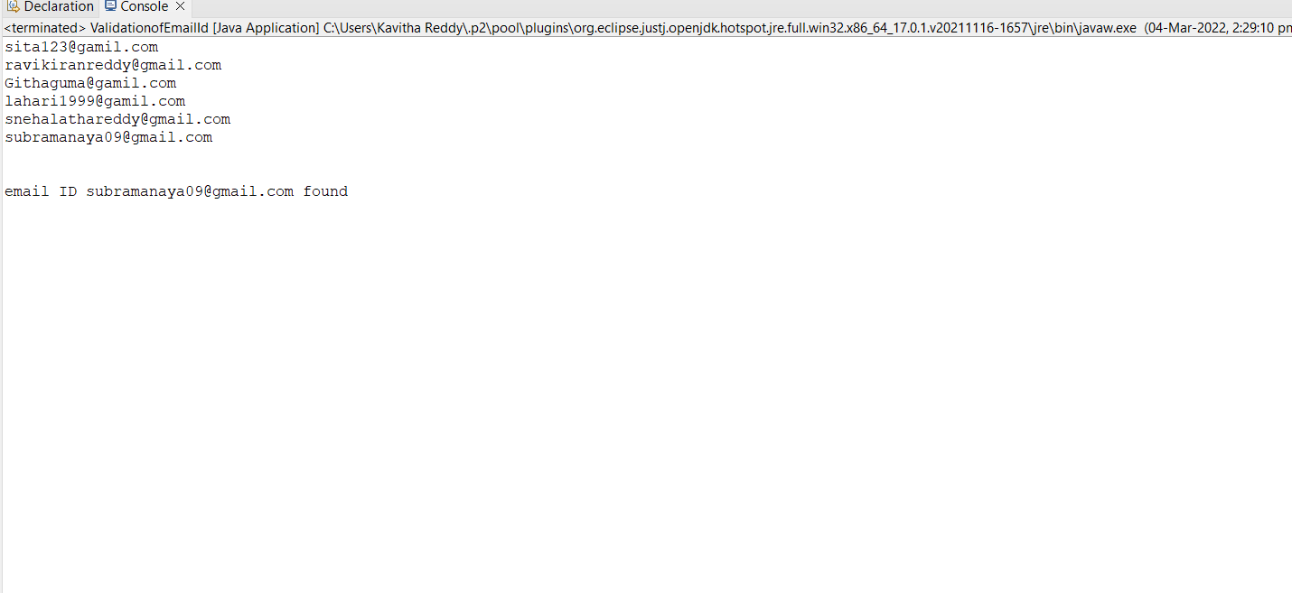

When we search particular email Id if it is present in the email id’s then it display searched email Id

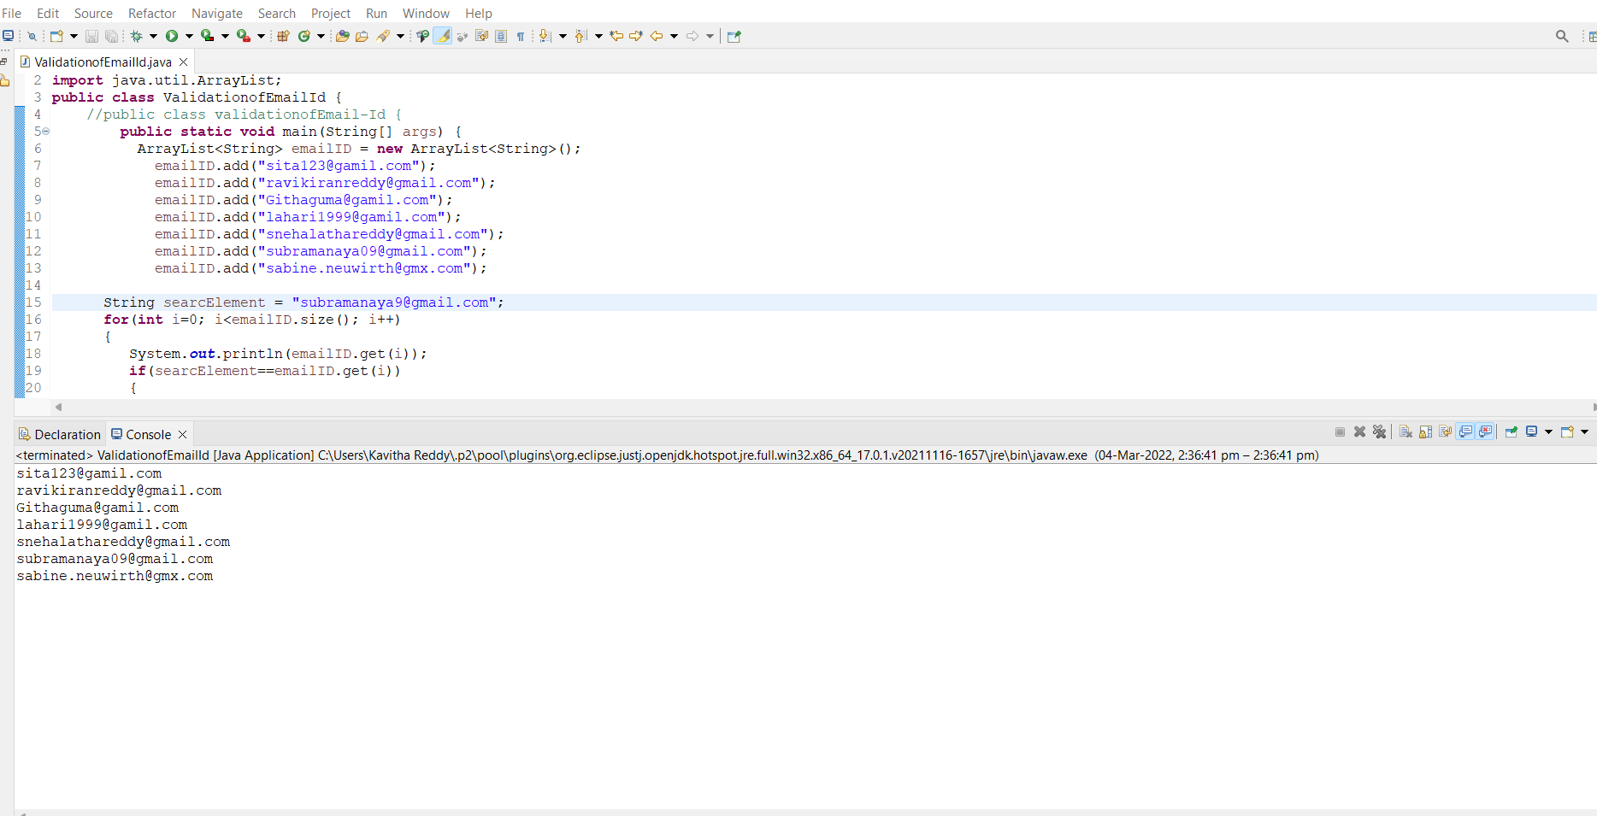

If we search wrong email Id it simply display all the email Id’s